Mount Royal University

COMP 2511 - Web I: Client Development
Assignment #2: Responsive Design/Accessibility



COMP 2511 Assignment #2: Responsive Design/Accessibility

Due date: March 28, 2025 – Before midnight, before 11:59 PM. Late assignments will be given a mark of 0.
Group Assignment: A group may consist of no more than 2 people.

This assignment intends to modify and improve your work from assignment 1 to create a website that is accessible by different people and is responsive across different devices. Web Accessibility and Responsive Web Design principles are important aspects of Web development that affect the experience of users with different abilities and devices.

Upon successful completion of this assignment the students will:

- Improve the accessibility of Websites based on an action plan.
- Know how to Grid layouts and to create responsive designs
- Style Websites to be responsive on devices with different sizes. (e.g., small screen, medium screen, and large screen devices)
- Use media queries to define multiple CSS style breakpoints for your websites.

Teamwork

You may choose to work in the same team as assignment 1 or you may work individually. Remember, for those working in a group, meet with your project partners to divide tasks equally. List all tasks and assign them to each member of the team in a planning document (README.txt). The planning document may change from your initial discussion. If you are doing this assignment solo, submit README.txt with a list of all the tasks that you have noted that need to complete. Clearly note any tasks that you did not complete!

Submission
All assignment files must be included in a folder and must be submitted via the I: drive, by the due date. No changes must be made to the project after the deadline. No extensions will be provided for submitting files incorrectly.
No late assignments will be accepted and no exceptions will be made for incorrect submissions.
Create a zip file called firstNamelastName or firstNamelastNamefirstNamelastName (if you worked in a group of 2) that contains all your files.
As discussed in labs, submit the zip file to the following folder: AcadShare1/Labs/CompSci/Submit/2511/001 or
AcadShare1/Labs/CompSci/Submit/2511/002

Part 1 - Re-designing the website
In this part of the assignment, you will be re-designing your website!
Content: Unless there were copyright or content issues identified for you when assignment 1 was marked, if you address them, you may base assignment 2 upon your previous products.
However, you are also welcome to develop entirely new content for assignment 2, as long as you fulfill the same copyright expectations, and the content is appropriate for an academic context. Offensive, hurtful and/or inappropriate content will not be marked and may result in you being reported to the MRU Student Community Standards office for non-academic misconduct.
Your professors encourage you to create a 'real' web-site that you consider publicly publishing via neocities.org or Git Pages. The opportunity to showcase your learning can be a valuable contribution to a student's portfolio.

CSS: You are free to relax the CSS requirements from the previous assignment and come up with a design of your choice. For the layout of the pages, you should follow the given layouts. Sample sketches are given in this document for small, medium, and large screens. You are expected to adjust the layout of your website for different screen sizes. A CSS reset (reset.css) is a set of styles you load prior to your other styles, to remove browser built-in styles. Normalize.css is a customizable CSS file that makes browsers render all elements more consistently and in line with modern standards. You can choose to work with reset.css but you MUST use normalize.css.

Sketches: Your website should look like the following sketches in small, medium and large devices. Your break points for small, medium, and large devices should be at 590 px, and 790 px.
- For small-sized devices, your page should be shown in 1 column format. The menu items can be shown vertically. Alternatively, you may use a hamburger menu component.
- For medium-sized devices, you will be using a 2X2 grid in the middle of your page.
- For large devices, the content should be centered with a fixed size of 790 px, and the remaining spaces on the side (mostly fluid design pattern) should have a plain color of your choice.
Note that these are simple sketches, feel free to adjust the sizes and spaces in your design.

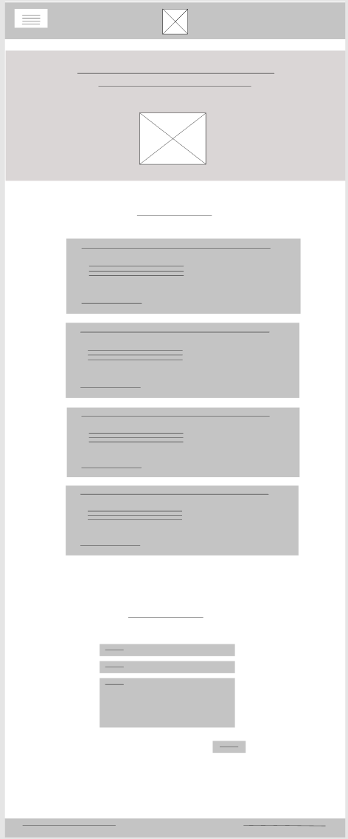 | 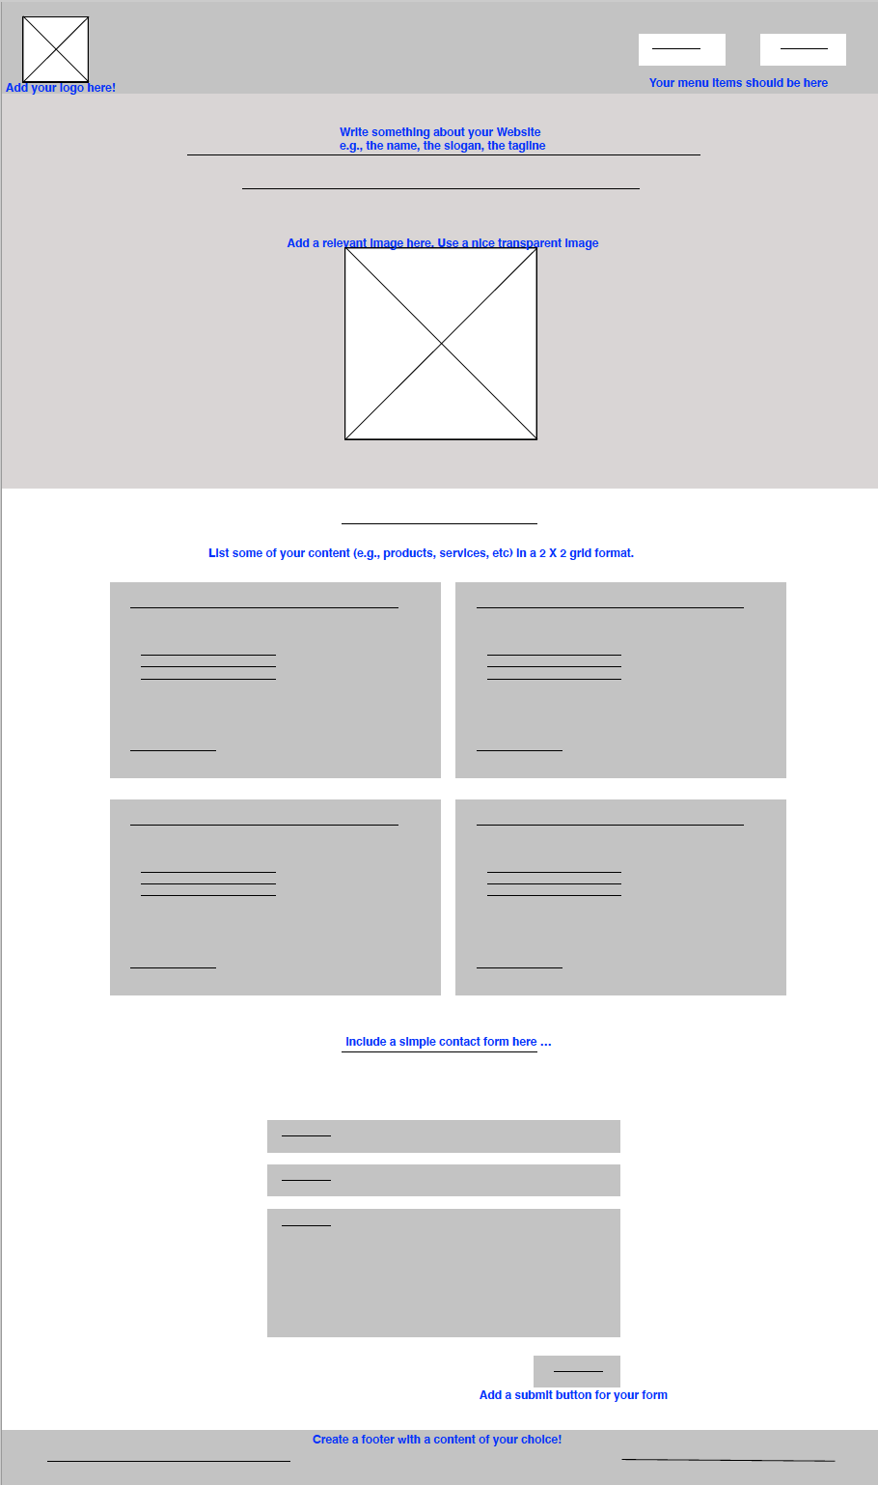
Small device | Medium device

Large device

Part 2 - Website Accessibility
Now, we will do some manual and automated analysis:

Manual analysis - Open your website and evaluate the accessibility of your website based on the accessibility topics that you have learned in class. You may find more criteria in the accessibility checklist provided by WebAIM https://webaim.org/standards/wcag/checklist. If you notice any issues, please fix them and improve the accessibility of your website to the best you can.

Automated analysis - Then, use the Wave accessibility tool at https://wave.webaim.org/ to check the issues in your website. Read the issues identified by Wave and fix them as much as you can!

In your README.txt file add the following content as well:
  - Document the issues you identified in each of the four categories (Perceivable, Operable, Understandable and Robust) as discovered through the manual and automated analyses above.
  - Describe the kind of changes you made. Don’t just list them; instead generalize the types of issues that you created when building your website, and then describe the generalized type of changes that you made to resolve those issues.

Grading

 | Points
General
The contribution of each team member must be visible in README.txt.
Design
The header is designed based on the given sketch. | 5
The section below header has a background, text, and picture and is designed based on the given sketch. | 10
The footer is designed with a custom content. | 5
Use of normalize.css. (mandatory)
All pages of the website follow the given layouts and designs have professional look. | 10
Responsive Design
The layout of the middle part of the pages (the middle 4 gray boxes shown in the sketches):  - follows a 1 column format, in small devices.  - follows 2X2 grid layout, in medium devices.  - follows mostly fluid layout, in large devices. | 6  12  12
Media queries are defined correctly to change to medium and large layouts at 590 px, and 790 px. | 15
Web Accessibility
The website is accessible: the accessibility criteria discussed in class are considered in the design of the page. The checklist posted on D2L has been considered as part of the evaluation. | 15
README.txt responses to the questions posted. | 10
Directory structure
Appropriate root and subfolder organization, naming conventions | 5
Functioning links, images, alt and other media | 5

